**Lesson 1: Learning Transportation Network/System Analysis**

**Introduction with the West Jordan Network**

**Submission type. Word Document.**

**You can work as a group of 3 students.**

**1.1.1 Data set:**

Folder \DTALite-NEXTA-Software-Package\Dataset_1_West_Jordan\West_Jordan_base_case

**Other resources:** **YouTube Video** for additional instructions

<https://www.youtube.com/watch?v=taIlhCl2Wic>

**1.1.2. Learning Objectives:**

1. Understand how to view/edit network attributes in NeXTA
2. Run a basic traffic simulation, comparing two different scenarios
3. Understand how basic network attributes affect traffic simulation results

**1.1.3. Background introduction**

The City of West Jordan will soon start a construction project to replace storm-water pipes under 9000 South between 1300 West and 700 West. In order to complete this project, 9000 South must be partially closed (from 2 lanes in each direction to 1 lane in each direction) to create a safe work zone for the repair crews. You (and an optional partner) have been tasked with using a Dynamic Traffic Assignment (DTA) model to evaluate the travel impacts (congestion, delay, etc.) associated with partially closing 9000 South.

This assignment will require preparing two different traffic simulation models - one in the initial condition (without the work zone), and one in the work zone condition. In preparing these two models, you will acquire the skills described in the following learning objectives.

# Step 1: Download and Open NeXTA, Open the West Jordan Network

Before going into too much detail, first makes sure you’re using the most up-to-date version of NeXTA, and open the West Jordan network.

**Step 1.3:** Open the West Jordan Network in NeXTA

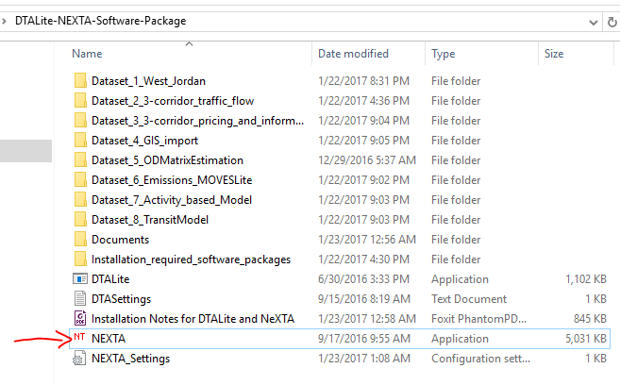

In NeXTA, go to File -> Open Traffic Network Project

In the Lesson 1, go to the DTALite-NEXTA-Software-Package\Dataset_1_West_Jordan\West_Jordan_base_case , select the **Base_Condition.tnp** file, and click **Open**

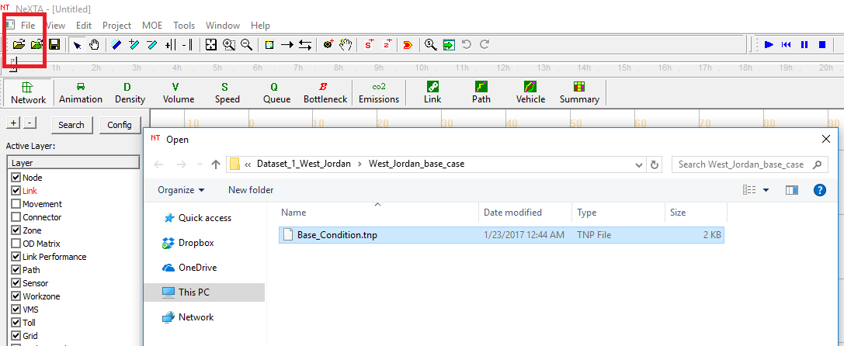

NeXTA will open the network, and display the **File Loading Status window**. The File Loading Status window displays information about the network currently open in NeXTA, including information about the number of links, nodes, and zones/activity locations in the network. This window can also be accessed by going to **File -> Check Data Loading Status**.

Background information about DTALite and NEXTA.

* Two software applications: NEXTA as GUI; DTALite as DTA simulation engine
* Data files are in CSV format: with geometric fields (for importing from and exporting to GIS)
* Project folder: *.tnp file as a reference for other data files:
  + One network per project folder
  + Prefix of input, output files



File structure:

* Different layers: different files: node, link, zone, activity locations
* Many model attribute files: node control type, link type, demand type and vehicle type
* Time representation: 24 hour (for demand and sensor data), day number= iteration number, work zone has day attributes (for modelling day-to-day learning)
* Scenario setting file: traffic flow model, traffic assignment model, scenario number for multiple scenario runs
* Scenario files for advanced modelling features: work zone, incident, tolling, VMS files
* Output files: simulation summary, network MOE, link MOE, trajectory file

Subfolders under internal release folder

* Documentation (for data structure, users guide)
* Test data sets (simple networks for testing traffic flow models and other key modelling features)

1. Basic GUI features
   1. Turn on and off GIS layers; Move around, select node and links; Toolbars for editing networks
2. View/Edit data files in NEXTA’s “project” menu
   1. Node/link/zone/activity location
   2. Demand meta database
   3. Scenario files
3. Integration with assignment model
   1. Traffic flow model; Assignment method
4. Advanced visualization functions of NEXTA
   1. 24-hour Time control/Clock bar
   2. Volume (bandwidth), density, speed
   3. Animation and queue: (turn off node layer and bandwidth)

**Problem 1:** How many nodes are in the West Jordan network? How many zones are in the West Jordan network?

**Step 2: Viewing/Editing Network Attributes in NeXTA**

Network objects primarily consist of links, nodes, and zones. A driver starts and ends their trip at a zone, traveling along road segments (links) between the origin and destination. Links are connected together at nodes, where a node may represent an intersection or a simple connection between two road segments.

Since vehicles only travel along links, passing nodes between their origin and destination, trip details (such as travel time, distance, speed, etc.) are heavily dependent upon link and node attributes. The most important link attributes are typically link length, speed limit, number of lanes, and capacity. Since nodes typically represent intersections, their important attributes typically include node control type (signalized intersection, stop-controlled intersection, no control, etc.) and traffic signal-related attributes.

This section will quickly explain how to view and edit these network object attributes.

**Step 2.1:** To quickly view most link or node attributes, simply select a link or node using the Select Object tool, and look at the attributes in the GIS Layer Panel in the bottom right corner of the screen. (Note, not all attributes are displayed in this panel.)

Link Attributes Node Attributes

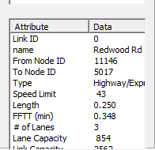 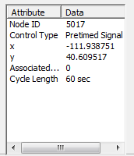

Alternatively, after selecting the link or node, right-click near the object and select either Edit Link Properties or Node Properties. Selecting Edit Link Properties opens the Link Properties dialog box, shown below. These dialog boxes offer the ability to edit individual link and node attributes quickly and easily - simply replace the text/values in the appropriate field, select OK, and click the Save button  on the Tool Bar to save your changes to the network.

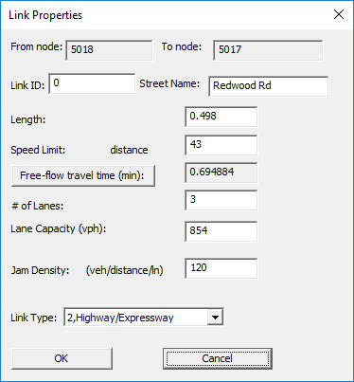

**Problem 2:** What is the speed limit along 9000 South? How many lanes are present along 9000 South in the Base Condition model?

**Problem 3:** Describe the link capacity on Redwood Road in the West Jordan Network (how link capacity varies by location, point out bottlenecks, etc.).

Hints: You can find file input_link.csv in the project folder (NEXTA menu->file->open project folder->locate input_link.csv) and use Excel to generate the histogram for the link capacity for all links with names of Redwood.

# 

# 

# Step 3: Running a Traffic Simulation

Since the objective is to evaluate the effects of the work zone located on 9000 South, we must prepare two networks - one with work zone and one without the work zone (initial condition). Before preparing the network, let’s run the traffic simulation for the initial condition to generate the simulation results which we will later use for comparison.

**Step 3.1:** Traffic simulations can be quite complex, with many different settings and options, but in this case the simulation settings have mostly been provided for us. To run the traffic simulation in NeXTA, simply click the  button on the MOE Toolbar. This will open a dialog box with simulation settings.

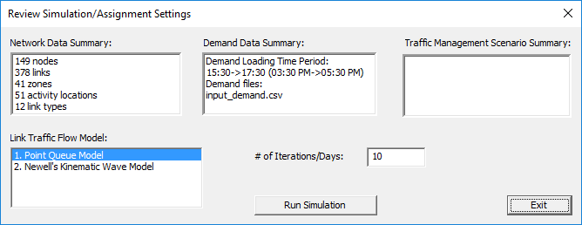

Please note that the current setting of **# of Iterations/Days** is 1. You can change it to more iterations/days, e.g. 10 iterations/days to obtain a converged network pattern. We’ll learn more about these settings in later lessons, but for now, simply press OK to start the simulation. Doing so will open the DTALite simulation window.

Allow the simulation to run until it is finished (the window will close automatically). Once complete, NeXTA will display another window describing the simulation run (shown below). Select Yes to view the simulation summary file (output_summary.csv).

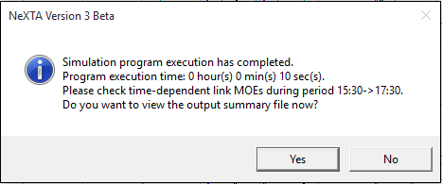

**Problem 4:** What is the number of agents/vehicles to be simulated, as reported in the output_summary.csv file?

**Problem 5:** The first large table in the output_summary.csv file describes summary statistics for each iteration of the simulation. What was the average travel time, average trip time index, average speed, and network clearance time (in minutes) for the last iteration? What pattern do you observe in the average travel times and speeds as the iteration number increases? (Plots might be useful to display these patterns/trends.)

**Step 4: Create the Work Zone Network**

When creating comparison networks, it is often a good idea to create a copy of the network first. We usually do this because we want to preserve simulation results and initial network attributes, as well as to make comparison easier (we can open multiple networks in NeXTA at the same time).

**Step 4.1:** Copy the West Jordan Network to create the work zone model. First, go to File -> Open Project Folder in NeXTA. This will open the folder containing the input files for the West Jordan network. Browse to the lesson 1 folder in the learning transportation folder, which contains the West Jordan network in the data sets. Copy the “West_Jordan” folder, and paste it within the same data sets folder, and change the folder name to “West_Jordan_Workzone”. Open this newly created folder and change the TNP file name from “Base_Condition.tnp” to “Workzone.tnp”.

**Step 4.2:** Open this new West_Jordan_Workzone model in NeXTA (following Step 1). Then, following the instructions in Step 2, reduce the number of lanes on all links between Node 1 and Node 3 (in both directions) to 1 lane, representing the work zone condition in which one lane is closed in each direction on 9000 South. **Remember to save the network after you finish editing the network to save your changes.**

**Step 4.3:** Run the traffic simulation again, following the instruction in Step 3. Open the output summary file to answer the following questions.

**Problem 6:** Similar to Problem 5, use the first large table in the output_summary.csv file to find the average travel time, average trip time index, average speed, and network clearance time (in minutes) for the last iteration? Do you notice many differences in these values compared to the results for the “no work zone” model?